1NT19IS172

SWETHA A

HIVE



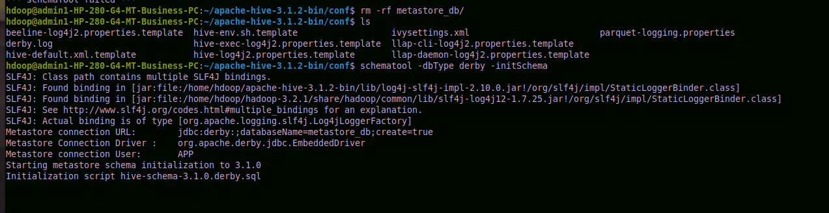

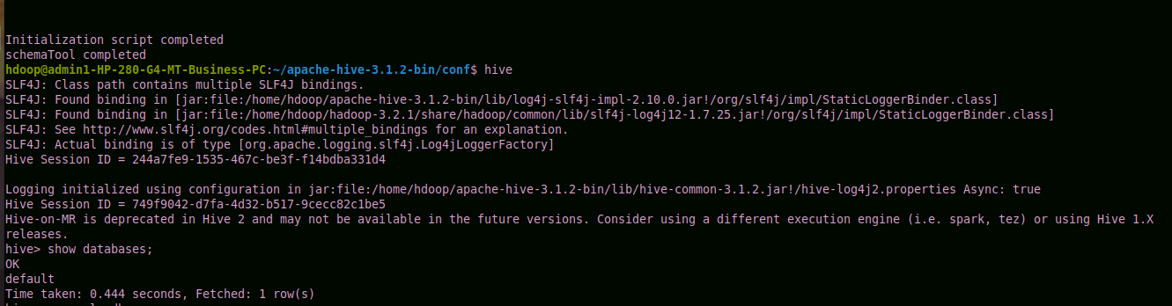

1. Insert 5 records using Insert command in HiveQL

create table sales(product string,price int,payment_type string,name string,city string,state string,country string);

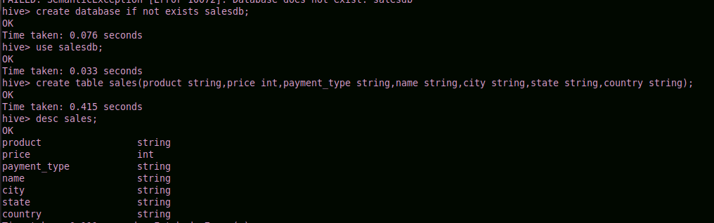

hive> insert into sales values('product201',1000,'Visa','madhuri','Bangalore','Karnataka','India');

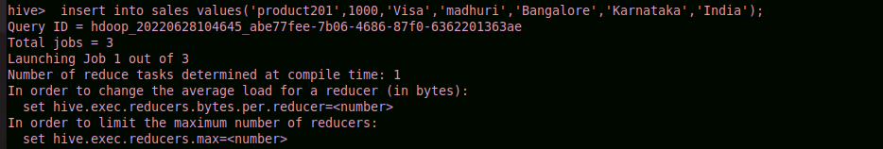

hive> insert into sales values('product202',3000,'Diners','shwetha','seattle','washington','usa');

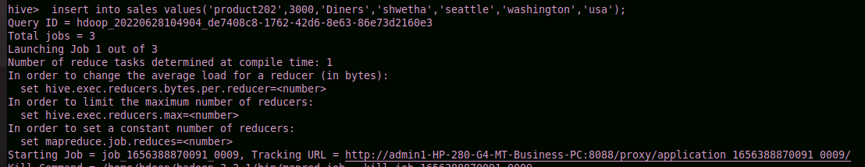

hive> insert into sales values('product203',3000,'Mastercard','bob','ontario','NJ','usa');

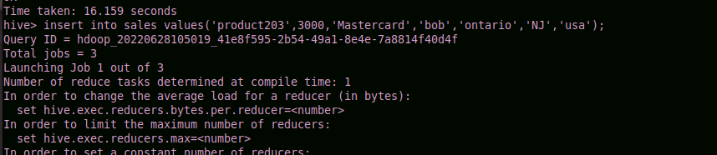

hive> insert into sales values('product204',3540,'Mastercard','bob','Mickleton','kk','usa');

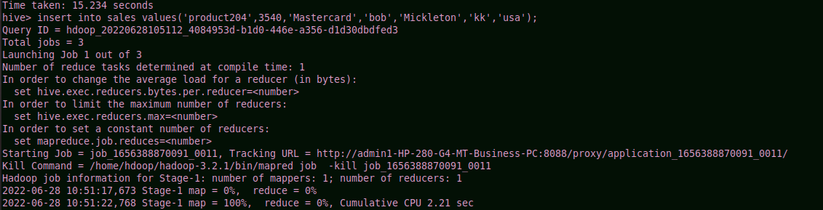

hive> insert into sales values('product205',3540,'Mastercard','charlie','hampton','NJ','usa');

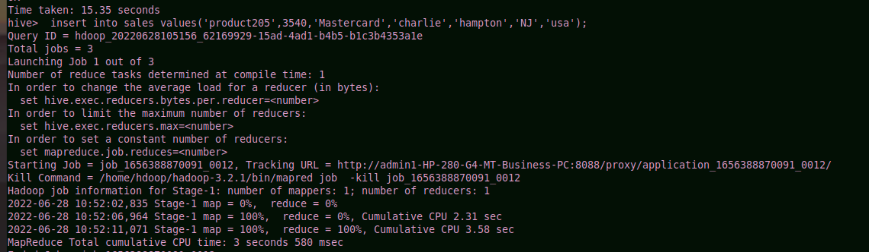

2. Import the dataset from the sales.csv

hive> load data local inpath '/home/hdoop/Desktop/sales.csv' into table sales;

Loading data to table salesdb.sales

OK

Time taken: 0.16 seconds

hive> select *from sales;

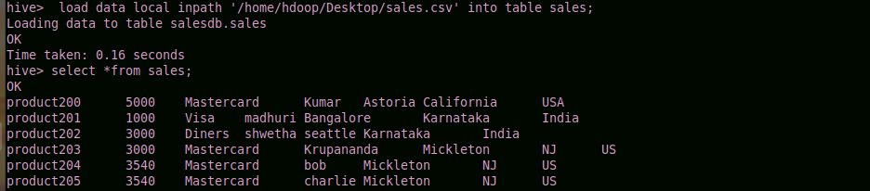

3. Count the number of sales done by each country

hive> select count(*) as count,Country from sales group by Country;

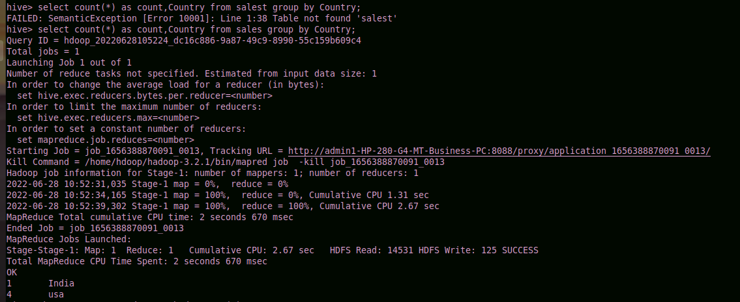

4. Count the number of sales done by each state

hive> select count(*) as count,State from salest group by State;

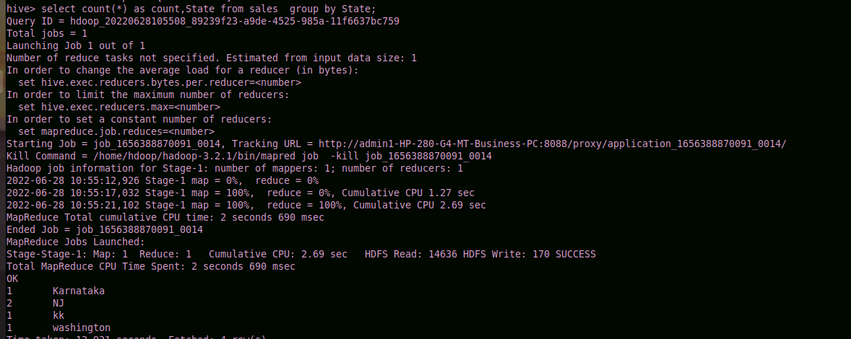

5. Display (Product, name) grouped by product

hive> select Product,name from sales group by Product,name;

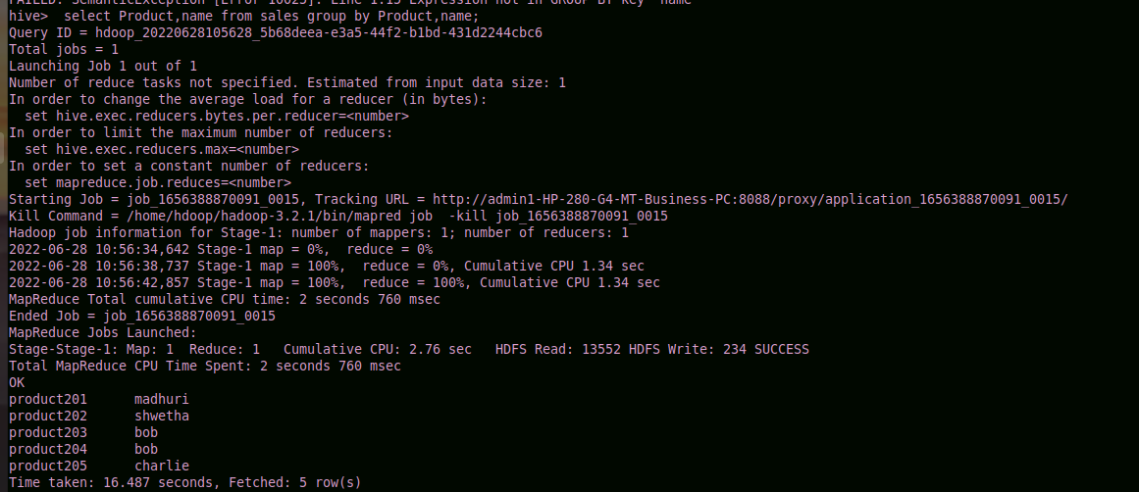

6. Create separate views for VISA and Mastercard

hive> create view visa as select *from sales where Payment_type='Visa';

OK

Time taken: 0.112 seconds

hive> select *from visa;

OK

product201 1000 Visa madhuri Bangalore Karnataka India

Time taken: 0.103 seconds, Fetched: 1 row(s)

hive> create view master as select *from sales where Payment_type='Mastercard';

OK

Time taken: 0.084 seconds

hive> select *from master;

OK

product203 3000 Mastercard bob ontario NJ usa

product204 3540 Mastercard bob Mickleton kk usa

product205 3540 Mastercard charlie hampton NJ usa

Time taken: 0.079 seconds, Fetched: 3 row(s)

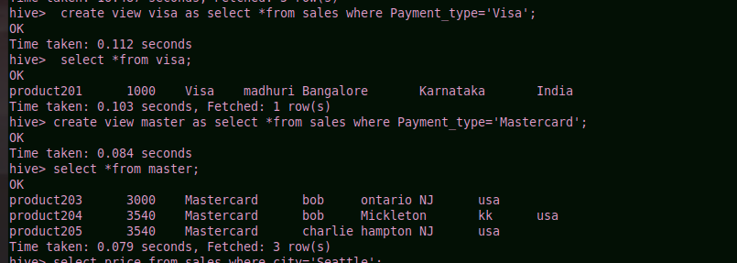

7. Show all the transactions done in Seattle

hive> select price from sales where city='seattle';



8. Find the max number of transactions done within the state of Ontario

hive> select max(Price) from sales where city='ontario' group by state;

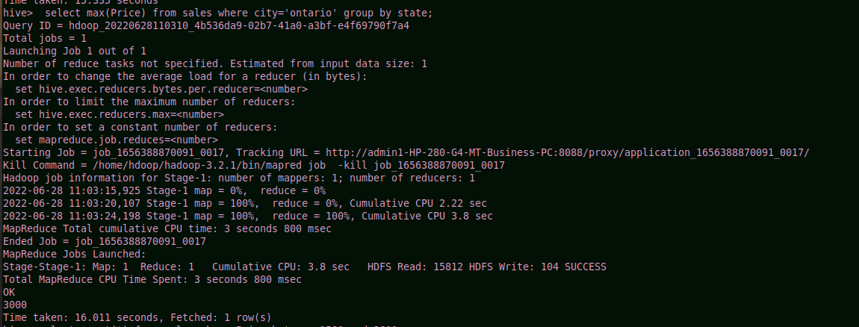

9. Find the number of transactions whose price is in between 1500-3600

hive> select count(*) from sales where Price between 1500 and 3600;

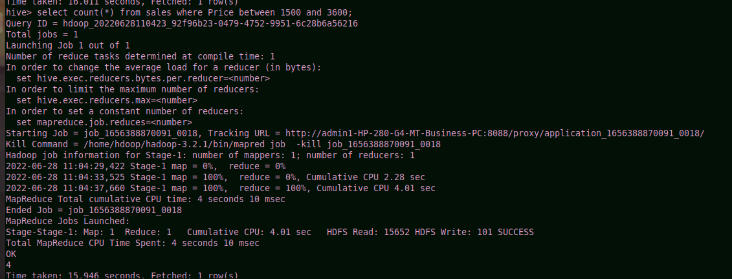

10. List all the transactions done in the United States using Mastercard

hive> select *from sales where Country='usa' and Payment_Type='Mastercard';

